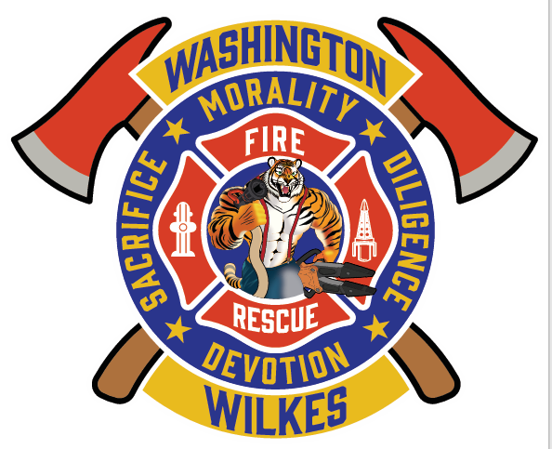
City of Washington – 2025 Basic Firefighter /EMT Employment Notice
Shift Work - 24/48 - 121 Shifts a year
Starting Salary: $15.00 hourly
Benefits:
- City paid Annual leave, Holidays, and Sick leave
- City-contributed Retirement Plan (3–5%)
- City-paid Employee Health Insurance
- City-paid Employee Life Insurance
- City-paid Cancer Insurance (Employee & Firefighter)
- Participation in Georgia Firefighters Pension Fund (with drills and volunteer involvement)

Minimum Qualifications:
- High School Diploma or GED
- Valid Georgia Driver’s License
- At least 18 years of age
- Must reside within 15 minutes of the Washington Fire Station
- Must successfully pass:
  - Background check
  - Oral interview
  - Physical exam
  - Drug screening
  - Physical performance evaluation
- Must be of good moral character and appearance
- Must meet Georgia Firefighter Standards & Training per O.C.G.A 25-4-1 (as amended)
- EMT certification preferred, or ability to complete certification within 2 years of hir

Desirable Knowledge, Skills, and Abilities:
- Ability to follow oral and written instructions effectively and quickly
- Strong decision-making under changing and adverse conditions
- Written communication skills for documenting incidents
- Physical stamina for strenuous tasks in challenging environments
- Mechanical skills for inspecting and maintaining equipment
- Teamwork and interpersonal skills to maintain strong working relationships

Essential Job Functions:
- Perform firefighting and lifesaving rescue duties
- Provide Basic Emergency Medical Aid
- Participate in ongoing training to enhance skills
- Drive and operate fire apparatus at incident scenes
- Inspect and maintain the fire station, equipment, and hydrants
- Engage in fire prevention programs and community outreach
- Lift, lower, and carry equipment (50+ pounds) during emergencies
- Climb and crawl in confined spaces
- Operate at various heights using ladders and ropes
- Participate in drills and volunteer events as part of job responsibilities

